timeseries test

Mehrab Atighi

1/19/2022

x = c(1.236,0.529,-0.552,0.198,-1.273,-1.006,0.291,-0.533,-1.175,-0.944,  
 1.713,2.006,0.854,-0.282,0.141,-0.151,-1.129,0.822,1.307,1.048,  
 2.157,0.66,-2.133,-2.996,0.367,1.143,0.187,1.170,0.389,0.666,  
 2.928,1.026,3.477,1.723,0.720,0.118,-1.954,0.272,1.617,1.152,  
 -1.365,-3.203,-0.017,1.698,2.230,-0.098,-0.704,1.094,-0.782,-1.717,  
 1.461,1.807,0.4,-0.354,-0.326,0.941,1.446,2.886,-0.416,-1.963,  
 -1.28,-0.655,2.088,0.844,-2.361,-0.761,2.393,1.951,-0.831,-1.111,  
 -0.735,-1.756,1.386,3.5,2.205,1.675,-0.068,-0.254,1.450,1.565,  
 1.624,0.634,2.203,3.201,2.741,2.352,0.297,0.259,1.308,-0.222,  
 -1.723,1.117,1.306,-1.333,-0.195,0.114,1.703,1.342,-1.234,-0.401)  
#a)  
  
plot(x , type = "o")

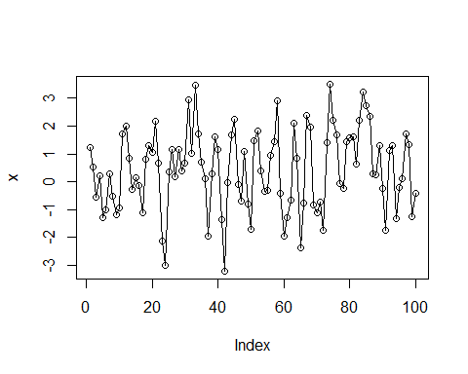

#b)  
a = acf(x)

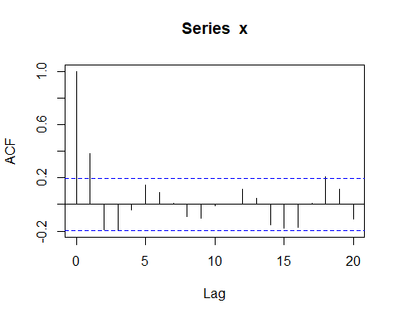

p = pacf(x)

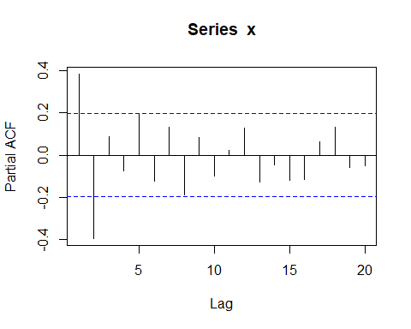

a$acf[1:5]

## [1] 1.00000000 0.38378644 -0.18889489 -0.18796471 -0.04284637

p$acf[1:5]

## [1] 0.38378644 -0.39425798 0.08945649 -0.07486718 0.19362712